Step by Step guide on How to File Your Nonresident Tax Forms (F and J)

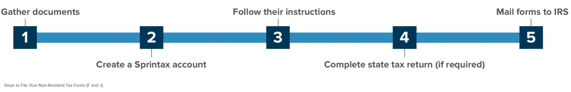
- Gather the documents you may need for Sprintax
 | Document | Description
✔ | Passport
✔ | Visa/Immigration information, including form I-20 (F status) or form DS-2019 (J status)
✔ | Social Security or Individual Taxpayer Identification Number (if you have one) | This is not needed if you had no income and the 8843 is the only form you have to file.
✔* | W-2 | This form reports your wage earnings if you worked. If you had more than one employer you should get a W-2 from each employer. It is issued by the end of January for the previous year. Make sure all employers from last year have an up-to-date address for you.
✔* | 1042-S | This form is used to report:  - stipend, scholarship, fellowship income and travel grants (not tuition reduction or exemption)  - income covered by a tax treaty  - payment for other types of services (eg by the semester as a note-taker)  If you received this type of income, the 1042-S will be mailed to you by 15 March by the payer.  Note: Only Nonresident Aliens receive this form. If your tax status changes to a Resident Alien you will not get a 1042-S. Login to Sprintax to check your tax status if you're not sure.
✔ | US entry and exit dates for current and past visits to the US | In addition to passport stamps, you can review or print your US travel history here
✔* | 1099 | This form reports miscellaneous income. Can be interest on bank accounts, stocks, bonds, dividends, earning through freelance employment
✘ | 1098-T | This form is NOT needed and can NOT be used for a nonresident tax return because NRAs are not eligible to claim education expense tax credits.

- Create a Sprintax Account:
You will receive an email from the international student office providing you with a link to Sprintax to set up your account as well as your unique discount code to use on Sprintax. Open your new Sprintax account by creating a UserID and password or if you have an existing account on Sprintax you can login using your existing credentials.
- Follow the Sprintax instructions
If you did not earn any US Income: Sprintax will generate a completed Form 8843 for you and each of your dependents (if you have any).
If you did earn US Income: Sprintax will generate your "tax return documents", including either a 1040NR-EZ or a longer form 1040NR, depending on your circumstances.
- (With U.S. income only) If required, complete your state tax return
After you finish your federal return, Sprintax will inform you if you need to complete a state tax return. If so, you will have the option to use Sprintax for an additonal fee. However, it is your choice to use them or to do the state tax return on your own.
- Read the instructions for filing/mailing your returns
Remember to read the instructions that Sprintax provides.
You will be required to download, print and sign your federal tax return and mail it to the IRS. If you have a state filing requirement, you must also mail this to the tax authorities.
Finally, if you only need to file Form 8843, this will also need to be mailed to the IRS.

